**Project 1 – Greatest of All Time (GOAT)**

Compare 6 great performances in 6 different sports by 6 different athletes. Use software (Excel, StatCrunch, MyStatLab/Pearson website apps) to complete the tasks below. Use the data in the Excel Spreadsheets that are provided.

**Tiger Woods 2000 Season:**

There is no arguing that the 14-time major winner’s finest season was 2000. Woods won the U.S. Open at Pebble Beach by 15 shots, the British Open at St. Andrews by eight strokes and beat Bob May in a playoff at PGA Championship at Valhalla Golf Club. Woods led all golfers in PGA Tour money winnings in 2000. The only golfer who was longer than Woods off the tee in 2000 was John Daly, who averaged 301.4 yards per tee shot. As you can see, Woods was almost 26 yards longer than the Tour average.

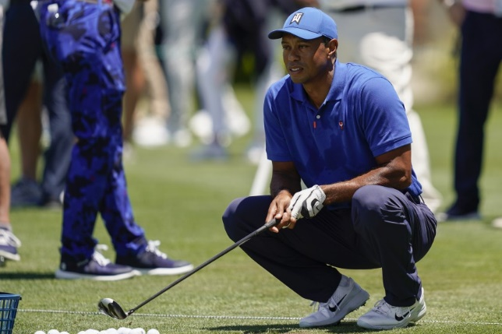 When it came to scoring, Woods of 2000 was in a class by himself. That year he had the lowest scoring average on par 3s, par 4s and par 5s, averaged more birdies per round than any other player, and his average score was almost three shots better than the Tour average. Tiger’s 2000 scoring average was 67.794. Since 2000, the only time any player has come within a shot of Woods’ scoring mark is when the Big Cat did it himself. Six times.

<https://golfweek.usatoday.com/2018/01/21/tiger-woods-dominant-2000-season-remain-one-for-the-books/>

**Wilt Chamberlain’s 1961-1962 Season:**

Not only did Chamberlain, the Philadelphia Warriors center, average a staggering 50.4 points, but poured in an NBA-record 100 points in a game against the Knicks on March 2, 1962. Chamberlain was 36-for-63 from the field and went 28-for-32 from the free-throw line in a 169-147 victory. Although 4,124 were in attendance, many thousands more would claim to have been there for decades afterward. 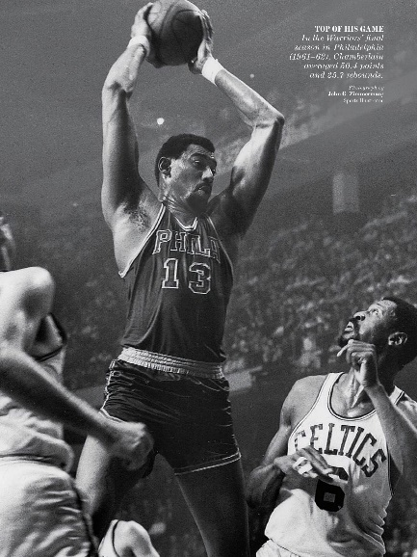

Aside from that scoring feat, Chamberlain proved he was plenty durable, too. He played in all but eight possible minutes for the Warriors and set single-season league records for minutes per game (48.5) and minutes played 3,882.

<https://www.nba.com/history/season-recap/1961-62#:~:text=The%201961%2D62%20season%20would,Knicks%20on%20March%202%2C%201962.>

**OJ Simpson’s 1973 Season:**

In 1973, Simpson had arguably the best season for a running back in NFL history. Simpson, the league MVP, surpassed Cleveland Browns running back Jim Brown’s single season rushing record of 1,863 yards. Not only did Simpson pass Brown, but he was the first back to rush for more than 2,000 yards in a season. Behind his offensive line, wittily nicknamed “The Electric Company” because they turned on “The Juice,” Simpson ran for 2,003 yards.

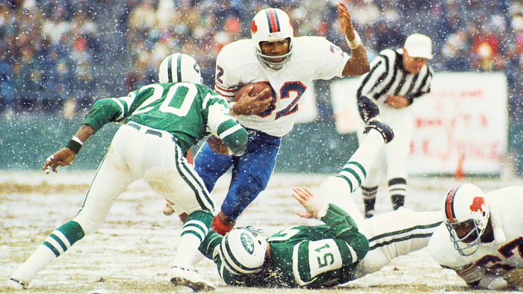 In the 42 seasons since Simpson’s record-breaking campaign, only six other running backs have bested his mark and joined him in the 2,000-yard club. Eric Dickerson of the Los Angeles Rams was the next back to net more than 2,000 yards in a season, gaining 2,105. Dickerson and his hip ’80s Jheri curl broke the record in 1984. Between ’84 and now, five other running backs have broken the 2,000-yard threshold, filling the space between Dickerson and Simpson.

Lost in the otherworldly statistics and talents of the names above is that only one man ran for 2,000 yards before 1978. In 1978, the NFL went from a 14-game regular season to the 16-game season, we now know. Simpson’s 2,003 yards in 14 games averages to 143.1 yards a game, the highest single season per game average in NFL history. Brown is a distant second at 133.1 yards a game.

<https://theundefeated.com/features/o-j-s-1973-season-is-best-of-any-running-back-ever/>

**Babe Ruth’s 1927 Season:**

From 1920-1932, Ruth averaged more than 46 home runs a season. In 1927, Ruth's record-setting season in which he hit 60 home runs, American League teams, excluding the [New York Yankees](http://bleacherreport.com/new-york-yankees), averaged 50 home runs. It was not unusual for Ruth to top the league average for home runs.

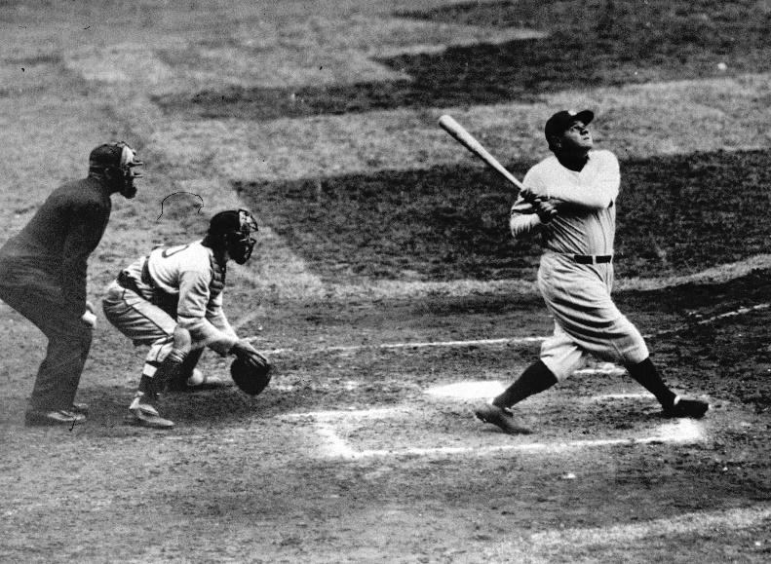 Ruth never struck out 100 times in a season. He led the league in strikeouts five times, but he never struck out more than 93 times. Ruth hit 714 home runs and struck out 1,330 times. He walked 2,062 times. When he hit 60 home runs, Ruth struck out 89 times, which calculates to one home run for every 1.48 strikeouts.

<https://bleacherreport.com/articles/1063119-babe-ruths-60-home-runs-was-a-greater-achievement-than-barry-bonds-73>

**Wayne Gretzky’s 1981 Season:**

Here is what has been said about the season Wayne Gretzky put together back in 1981-82. After taking a couple of seasons to “find his stride” at the NHL level, in which he posted a ridiculous 106 goals and 301 points in 159 games, No. 99 started to kick things into gear during his third year in the league.

 From 1981-1986, Gretzky collected a mind-numbing 1, 036 points in just 394 games. He scored an absurd 375 goals and “chipped in” 661 assists for good measure. Simply do the math and you will see Gretzky scored at an astonishing clip of 2.63 points per game over a five-year period. No matter how you look at it, the numbers are just staggering and as impressive as that run was, the year that stands out above all the rest was the aforementioned 1981-82 campaign. While some would argue that his 1983-1984 season of 87 goals and 205 points in 74 games was even better, in my mind, that argument loses steam once you take his surrounding cast into consideration.

In 1981-82, the Oilers did manage to break the 400-goal barrier for the first time, finishing with “only” 417. Gretzky had his hand in on 50.9% of the Oilers goals that season and it was the start of what many consider the most dominant run of any one player in professional team sports history. His performance erased all doubt as to who was the best player in the game and it wasn’t even close.

<https://thehockeywriters.com/oilers-history-wayne-gretzky-and-a-season-like-no-other/>

**Serena Williams’ 2013 Season:**

Serena’s 78 wins in 2013 are 20 more than she had in any other season. *Twenty!*

Her 11 tournament titles and 13 finals are the most of her career. (In 2002, she had eight and 11, respectively.) From 2010-2012, Serena won a *total* of 11 tournaments. Also, the 11 wins are the most for any WTA player since Martina Hingis had 12 in 1997. The last player to win more than 11 before Hingis was Steffi Graf in 1989.

Serena’s 95% winning percentage is the highest of her career.

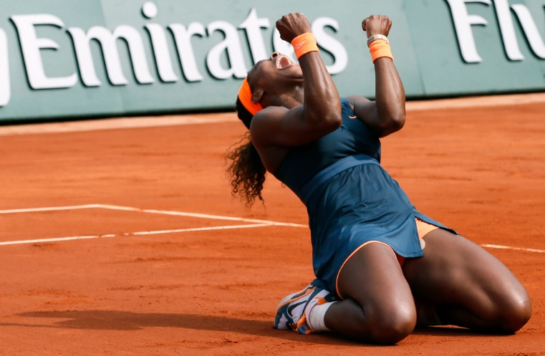 (Getty Images) She won in Miami, Madrid, Rome, Canada, Beijing and at the WTA Championships. That’s six wins in Mandatory Premiere and Premier 5 tournaments. In the past eight years, Serena won seven titles in those tournaments. She also took home her first French Open title in more than a decade.

Serena had 13,260 rankings points in 2013. World No. 2 Victoria Azarenka had 8,046. The gap between Serena and Vika (5,014 points) is about the same as the one between Vika and world No. 16 Ana Ivanovic.

<https://ftw.usatoday.com/2013/10/serena-williams-2013-wta-championships-best-year-career>

1. Use Z-Scores to compare 6 great performances in 6 different sports by 6 different athletes:

|  |  |  |  |  |  |  |
| --- | --- | --- | --- | --- | --- | --- |
| Sport | Year | Athlete | Statistic | Value | Z-Score | Probability |
| Football | 1973 | OJ Simpson | Yards Gained Rushing (Season) |  |  |  |
| Basketball | 1961-1962 | Wilt Chamberlain | Points per Game Average (Season) |  |  |  |
| Baseball | 1927 | Babe Ruth | Home Runs (Season) |  |  |  |
| Hockey | 1981 | Wayne Gretzky | Goals Scored (Season) |  |  |  |
| Golf | 2000 | Tiger Woods | Strokes Per Round Average (Season) |  |  |  |
| Tennis | 2013 | Serena Williams | Aces - Season |  |  |  |

Based on the Z-Scores whose performance was the most impressive?

Why is a Z-Score comparison appropriate? Why do you think Serena’s Z-Score was lower than the others? Does this make you want to get another set of data for her?

2. Look at the ***second highest*** Z-Score in each year. Fill in the table below:

|  |  |  |  |  |  |  |
| --- | --- | --- | --- | --- | --- | --- |
| Sport | Year | Athlete | Statistic | Value | Z-Score | Probability |
| Football | 1973 |  | Yards Gained Rushing (Season) |  |  |  |
| Basketball | 1961-1962 |  | Points per Game Average (Season) |  |  |  |
| Baseball | 1927 |  | Home Runs (Season) |  |  |  |
| Hockey | 1981 |  | Goals Scored (Season) |  |  |  |
| Golf | 2000 |  | Strokes Per Round Average (Season) |  |  |  |
| Tennis | 2013 |  | Aces - Season |  |  |  |

3. Compute the ratio of the highest Z-Score in each year to the second highest Z-Score. Fill in the following table:

|  |  |  |  |  |  |  |
| --- | --- | --- | --- | --- | --- | --- |
| Sport | Year | Athlete with Top Z-score | Top Z-Score | Athlete with 2nd Z-score | 2nd Z-Score | Ratio of top Z-Score to 2nd Z-Score |
| Football | 1973 |  |  |  |  |  |
| Basketball | 1961-1962 |  |  |  |  |  |
| Baseball | 1927 |  |  |  |  |  |
| Hockey | 1981 |  |  |  |  |  |
| Golf | 2000 |  |  |  |  |  |
| Tennis | 2013 |  |  |  |  |  |

What does this tell you about the performances of the athletes?

4. Considering Z-Scores or not, which performance by which athlete is your favorite? Why?

5. Your report must be created in **M/S Word**. (If you are using the Apple word processing/ desktop publishing apps **Pages,** which is typically a part of the iWork suite and includes, **Keynote** (presentation) and **Numbers** (spreadsheet); they can all export into M/S Office). Your report must answer the questions above. Only filling in the tables is not sufficient. Your analysis is as important as your data collection and your calculations.